BIRD PHOTOGRAPHY FROM HIDES
Kiskunsag, HUNGARY
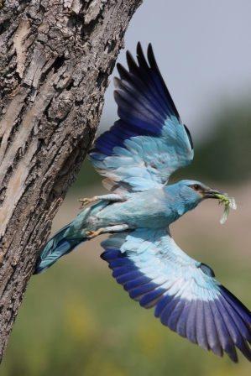
We use several different areas and habitats with different specialized hides. Our basic programme offer is 7 days with one arrival and orientation day, spending at each different areas and hides minimum 1 full day and on departure day an optional extra half day photography if time permits. Each hide offers comfortable space for 2 photographers. Photographers will spend time at each hide in a rotating system.
Day1
After arrival to Budapest Airport either a quick 1-1,5-hour-long transfer to Kondor EcoLodge or checking out habitats and photographing birds as we go in the Kiskunsag National Park, arriving in the evening to the accommodation. Depending on arrival time checking the areas & hides

Day2-6
Spending full days in a rotating system at one of the professional hides from the below list:
Hides at Kondor EcoLodge, Kiskunsag National Park, HUNGARY

- Drinking & Feeding Station Hide – Sparrowhawk, Common Redstart, Long-tailed Tit (Northern form), Hawfinch, Tree Sparrow
- Mobile Hides – Roller, Bee-eater, Hoopoe, Tawny Pipit, European Nightjar, Red-backed & Lesser Grey Shrike

The following species can be seen and photographed in the garden of Kondor EcoLodge during a year:
Sparrowhawk, Honey Buzzard, Common Cuckoo, Scops Owl, Tawny Owl, European Bee-eater, Lesser Spotted Woodpecker, Middle Spotted Woodpecker, Great Spotted Woodpecker, Wryneck, European Hoopoe, Common Redstart, Black Redstart, Mistle Thrush, Chiffchaff, Icterine Warbler, Willow Warbler, Blackcap, Lesser Whitethroat, Goldcrest, Firecrest, Spotted Flycatcher, Long-tailed Tit Northern form, Great Tit, Blue Tit, Nuthatch, Short-toed Treecreeper, Eurasian Golden Oriole, Wren, Tree Sparrow, Linnet, Chaffinch, Goldfinch, Greenfinch, Hawfinch, Yellowhammer, Siskin

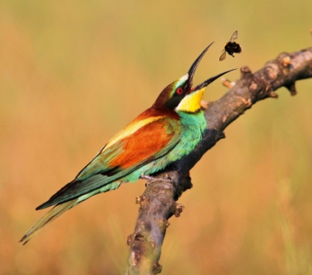
The furthermore species can be seen and photographed, walking distance from our Kondor EcoLodge during a year:

White Stork, Marsh Harrier, Montague’s Harrier, Common Buzzard, Saker Falcon, Eurasian Kestrel, Common Quail, European Turtle Dove, Little Owl, European Nightjar, European Roller, Black Woodpecker, Syrian Woodpecker, Skylark, Crested Lark, Wood Lark, Swallow, House Martin, Sand Martin, Tree Pipit, Tawny Pipit, White Wagtail, Yellow Wagtail, European Robin, Common Nightingale, Whinchat, Stonechat, Northern Wheatear, Red-backed Shrike, Lesser Grey Shrike, Corn Bunting

B. Hides at other parts of Kiskunsag National Park, HUNGARY:

- Red-footed Falcon Tower Hide – Red-footed Falcon, Turtle Dove, Roller
- Alkaline Lake Shorebird Hide - Black-winged Stilt, Avocet, Little Ringed Plover, Marsh Sandpiper
- Freshwater Lake Floating Hide – Ferruginous Duck, Spotted Crake, Squacco Heron
- Roller Hide
- Little Owl Hide
- Hoopoe Hide
- Raptor feeding station and hide - White-tailed Eagle, Imperial Eagle, Rough-legged Buzzard, Hen Harrier

Some of the Species which can be photographed from different hides in the Kiskunsag National Park:
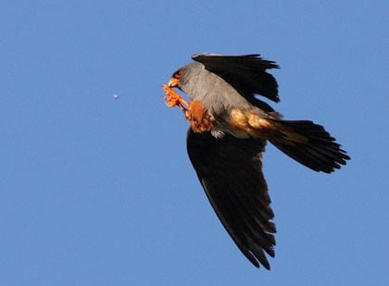
Pygmy Cormorant, Great White Egret, Little Egret, Grey Heron, Purple Heron, Squacco Heron, Bittern, Little Bittern, Spoonbill, Sparrowhawk, Red-footed Falcon, Black-winged Stilt, Avocet, Little Ringed Plover, Lapwing, Dunlin, Curlew Sandpiper, Ruff, Marsh Sandpiper, Wood Sandpiper, White-winged Tern, Whiskered Tern, Turtle Dove, Common Cuckoo, European Bee-eater, European Roller, Lesser Spotted Woodpecker, Middle Spotted Woodpecker, Great Spotted Woodpecker, Little Owl, Golden Oriole, European Hoopoe, Common Redstart, Black Redstart, Blackcap, Lesser Whitethroat, Long-tailed Tit Northern form, Nuthatch, Red-backed Shrike, Lesser Grey Shrike, Tree Sparrow, Hawfinch, Chaffinch, Goldfinch, Greenfinch, Yellowhammer
Day7
After breakfast final morning Photography session at Kondor EcoLodge and/or vicinity. Midday transfer back to Budapest Airport.

